Q1 Describe the Joux’s three-party Diffie-Hellman protocol

Q2 What is the (min) order of the following multiplicative groups defined by the chosen parameters p and g:
[hint: 593, 1187, 3559 primes, with 1187 = 2 x 593 + 1 and 3559=593 x 2 x 3+1 → with the exception of (2), no need to do any modular exponentiation! – NOTE: EXPLAIN YOUR ANSWER otherwise answer is not valid]

1) g^{x} mod p, with g=1186, p=1187

2) g^{x} mod p, with g=7, p=1187

3) g^{x} mod p, with g=9, p=1187

4) g^{x} mod p, with g=64, p=3599

Q3 Describe the Pedersen Verifiable Secret sharing

Q4 Being e: GxG→Gt a bilinear map, and g a generator of G, simplify the expression:

e(gª g^{b}, g^{c} g^{d}) / e(g^{ac}, g^{bd})

E1. Consider the Elliptic curve y² = x³ - 2x - 3 defined over the modular integer field Z₅.
- find all the points EC(Z₅) and state what is the order of the corresponding group
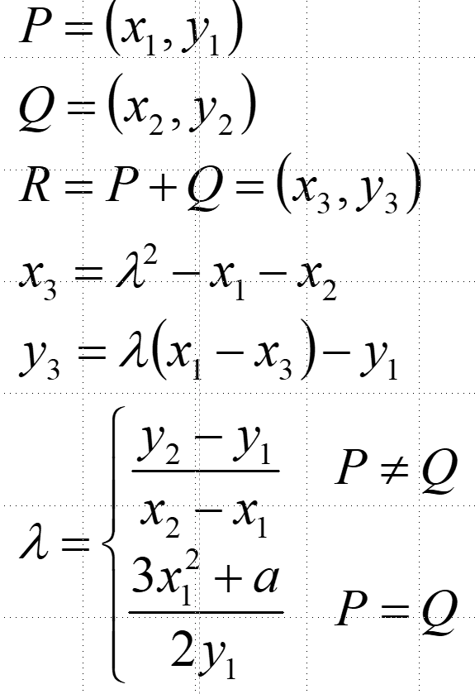

- Compute [4](1,1)
[HELP: possibly useful mnemonic hints reported here on the right;
MUST-DO: show step-by-step detailed computations; try to minimize the number of EC additions]

E2 – Secret Sharing and Threshold RSA. A group of four parties forms a (3,4) secret sharing scheme. Using ordinary arithmetic (no moduli) parties P_{i}={1,2,3,4} are dealt with shares σ_{i} of a key SK, which is the private key of an RSA scheme with modulus n=91 and public key PK=5.

A. Using shares σ₁=34, σ₂=41, σ₄=61, reconstruct the secret key SK and verify that it is the correct one for the considered RSA public key PK;

B. If the attacker only knows shares σ₁ and σ₄, and does not yet know share σ₂, what’s his/her advantage in terms of chances to guess the secret key versus a pure random guess? [ignore here the further info that SK is an RSA secret key]

C. Using the Shoup construction, show step by step how the three parties P1, P2 and P4 can distributely compute a threshold RSA signature for the message m=15, and verify that the result is correct by directly computing the signature using the SK value computed before.
[NOTE: if you prefer, to simplify computation instead of using the full L! you can use the minimum value that permits to make all lambda coefficients integer] [HINT: 15⁻¹ mod 91 =85]

